A Mini Project Report
On
Health Recommender Systems
Submitted in partial fulfillment of the
Requirements for the award of degree of

Bachelor of Technology
In
Computer Science and Engineering

by
Tooprani Manoj,
(14H61A05B7)

K.Sai Prasad,
(14H61A0586)

Aditya Parlikar
(14H61A0562)

Under the Guidance of
Mrs. M.Sridevi
Associate Professor, CSE Dept.


ANURAG GROUP OF INSTITUTIONS
(Formerly CVSR College of Engineering)
(An Autonomous Institution, Approved by AICTE and NBA Accredited)
Venkatapur (V), Ghatkesar (M), RR Dist., T.S-500088
Department of Computer Science and Engineering



CERTIFICATE
This is to certify that the project entitled “Health Recommender Systems” being submitted by Tooprani Manoj bearing the Hall Ticket number 14H61A05B7, K.Sai Prasad bearing the Hall Ticket number 14H61A0586 and Aditya Parlikar bearing the Hall Ticket number 14H61A0562 in partial fulfillment of the requirements for the award of the degree of the Bachelor of Technology in Computer Science and Engineering to Anurag Group of Institutions (Formerly CVSR College of Engineering) is a record of bonafide work carried out by them under my guidance and supervision from July 2017 to Oct 2017.
The results presented in this project have been verified and found to be satisfactory. The results embodied in this project report have not been submitted to any other University for the award of any other degree or diploma.

Internal Guide External Examiner Mrs. M.Sridevi,
Associate Professor

Project Coordinator Pallam Ravi
Asst.Professor

Dr.G.Vishnu Moorthy,
Deputy Director and Head, Dept. of CSE

ACKNOWLEDGEMENT

It is our privilege and pleasure to express profound sense of respect, gratitude and indebtedness to our guide Mrs. M.Sridevi, Assoc.Prof, Dept. of Computer Science and Engineering, Anurag Group of Institutions (Formerly CVSR College of Engineering), for her indefatigable inspiration, guidance, cogent discussion, constructive criticisms and encouragement throughout this dissertation work.
We express our sincere gratitude to Dr. G.Vishnu Moorthy, Professor & Head, Department of Computer Science and Engineering, Anurag Group of Institutions (Formerly CVSR College of Engineering), for his suggestions, motivations and co-operation for the successful completion of the work.
We extend our sincere thanks to Dr.K.S.Rao, Director, Dr.V.Vijaya Kumar, Dean, Dept. of CSE & IT, Anurag Group of Institutions (Formerly CVSR College of Engineering), Venkatapur (V), Ghatkesar (M), Ranga Reddy (Dist), for their encouragement.

Tooprani Manoj -14H61A05B7
Sai Prasad - 14H61A0586
Aditya Parlikar -14H61A0562

DECLARATION

We hereby declare that the project work entitled “ Health Recommender Systems” submitted to the Anurag Group of Institutions(Formerly CVSR College of Engineering) in partial fulfillment of the requirements for the award of the degree of Bachelor of Technology (B.Tech) in Computer Science and Engineering is a record of an original work done by us under the guidance of Mrs. M.Sridevi, Associate Professor and this project work have not been submitted to any other university for the award of any other degree or diploma.

Tooprani Manoj -14H61A05B7
Sai Prasad - 14H61A0586
Aditya Parlikar -14H61A0562

Date:

Abstract
A Health Recommender System (HRS) is a specialization of a Collaborative filtering Recommender System. The main aim of an HRS is to supply its user with the list information of best Hospitals and doctors which is meant to be highly relevant to the medical development of the patient associated with that HRS.Collaborative filtering is a method of making automatic predictions about the interests of a user by collecting preferences information from many users. In collaborative filtering the recommendations are made by considering ratings of similar users. Depending on a user's medical expertise an HRS should suggest Hospitals, which is comprehensible to that user. By selecting the highest ranking documents or media content a patient is empowered in terms of health information acquisition. Thereby, the risk to retrieve “incomplete, misleading and inaccurate” can be reduced. So, our proposed system tries to give the data related to patient/user’s history. The recommendations are made on the basis of user’s history.
Keywords:. collaborative filtering,health recommender system.

CONTENTS
S.No Page No.
1. Introduction 7
1.1 Scope 7
1.2 Objective of the Project 8
1.3 Software Requirements 8
1.4 Actvity flow of the System 8
1.5 Existing System 9
1.6 Proposed System 9
2. Software Requirement Specifications 10
2.1 Use Cases for each Actor 11
2.2 Programming Files 13
2.3 User Manual for each User 24
3. Database/E-R Diagram 27
4. Test Cases 32
5. Deployment 34
5.1 Deployment Diagram 34
5.2 Screenshots 35
6. Conclusion 39
6.1 Project Conclusion 39
6.2 References 39
1. INTRODUCTION

1.1 Scope
hrecommender is a website created with a aim to help those people who seek advice regarding Hospitals and Doctors. With the goring technology, no amount of knolwdge especially regarding health can be trusted on the internet until and unless it has come from a genuine source,. What our webste does is, whenever a person rates a hospital and doctor, it stores the ratings of that individual and dynamically updates the rating of Hospital and Doctor. Once the user signsup with the website, he/she can look up from a list of top doctors across various fields working in different hospitals which is provided to the user whenever he needs. The user gets to rate each particular doctor and hospital on various criterions. Alongside, the website also stores the health history of the user with the help of which we suggest the best doctors that might help the user cure.
1.2 Objective of the Project
This object paves the way to accomplish an easier way for the people to decide which hospital and which doctor to visit to. A user can now store his medical history online and also search for top rated hoespitals and doctors accordingly as per his needs. Since the ratings are updated with each user’s rating and suggestions are made upon that, the Website can be trusted with its genuinity.

1.3 SOFTWARE REQUIREMENTS
1. Client-side Technologies : HTML,CSS,Javascript,Bootstrap
2. Server-side Technologies : PHP
3. Database : MySQL
4. Operating System : Windows 7,8,10
5. Softwares : WAMPP Server

1.4 Activity Flow of the System
Activity diagrams are graphical representations of workflows of stepwise activities and actions with support for choice, iteration and concurrency. In the Unified Modeling Language, activity diagrams are intended to model both computational and organizational processes (i.e. workflows).Activity diagrams show the overall flow of control.
The activity starts with the customer registering with the website. The next activity is, the user will login and enter personal details and his medical history. Once all the data asked is given, our website stores it in the user’s history. The user can login whenever he wants to. He can also give the ratings to different hospitals and doctors from the list that he may have visited to. Once the ratings are given, our website provides the user with the information of hospitals and doctors that different users have given similar ratings to. The user can also choose top most hospitals and top most doctors which has been calculated considering the ratings of each and every user.
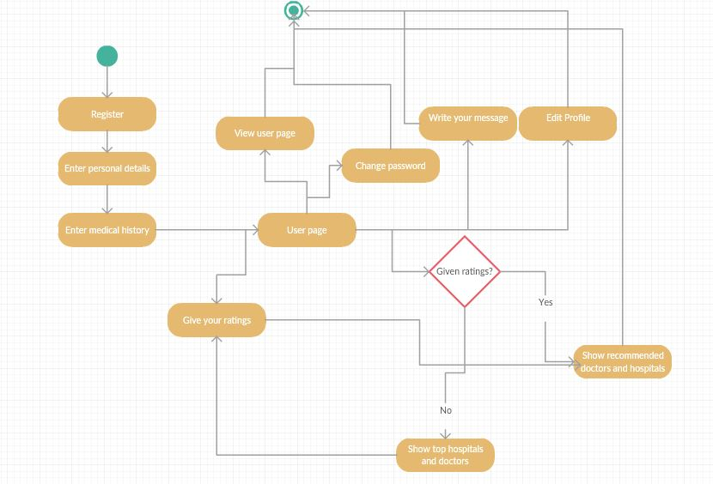
figure1: Activity Diagram for health recommender system
Workflows:
Admin:
Admin is given a user id and password to login.He is given the following privileges.
1.view users,doctors and hospitals.
2.Block/unblock users.
3.checks the feedback
His workflow ends with the log out.
User:
The User needs to Sign-up with the website in order to access the Service.
1. views hospitals
2. views doctors
3. gives ratings
4. edits profile
The user can come across various hospitals and doctors across various fields.
His workflow also ends with the logout action.
1.5 Existing System
In the existing systems,the user should search each and every thing and located manually. No recommendations are given to the user. Every piece of information is displayed to the end user only.
1.6 Proposed System
Through this project, we suggest an easy,user-friendly and convenient way of displaying services at one place. The information given to the end user is filtered through collaborative filtering.

2 Software Requirement Specifications

USE CASE DIAGRAMS
A use case diagram at its simplest is a representation of a user's interaction with the system that shows the relationship between the user and the different use cases in which the user is involved. A use case diagram can identify the different types of users of a system and the different use cases and will often be accompanied by other types of diagrams as well.
Here, user is the main heart of our system. We provide so many options to maintain the administration functions. The client (admin/user) has to give username and password. But the client cannot connect to the server by just giving information to the server. If both the username and password are valid, only then the user/admin will be able to access the application.

Actors and Description:
The actors in this project are:
- Admin
- User
Description:
- Admin : The admin is the developer of the website. The Admin is the actor who looks upon all the requests generated by the user and makes sure that they are addressed. The admin also looks up to the errors or bugs that might occur.
- User : Here comes the main actor. The entire process starts with the customer who registers with the website. The user is first provided with the list of top rated hospitals across the city of which he can select any hospital depending on his needs.
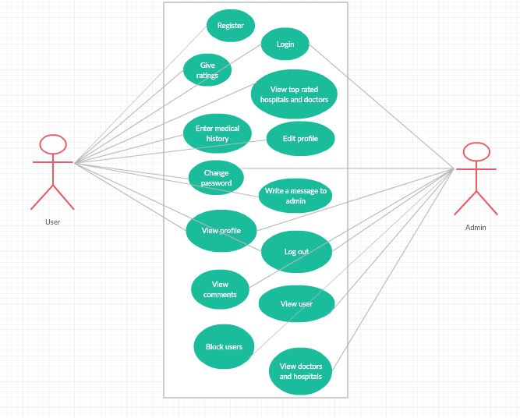
figure2: Usecase Diagram for health recommender system

2.1 Use Cases for each Actor:
User (Register,login,views website,gives feedback):
The user is the actor to which the use cases signup, login, view recommendations, give ratings, view and update profile are associated. Signup is the use case which provides the user to register and get the account. The Signup use case which is to be given by the user at the time of registration. After registering the user needs to login to the website. After logging in, the views website use case. The view recommendations use case where the website provides the user with recommended hospitals and doctors.
The give ratings use case under which a user can give ratings to hospitals and doctors.
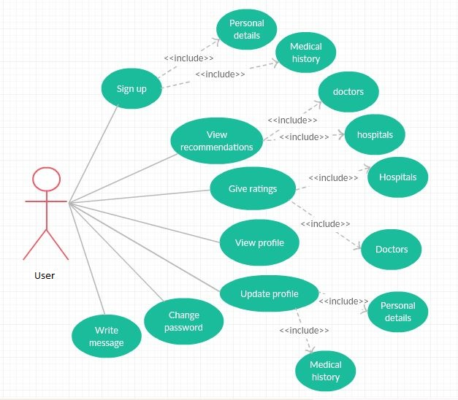
figure3: Usecases for user

Admin (login,updates database,views feedback):
The admin is the actor to which view comments, users, hospitals, doctors, profile and change password usecases are associated. The view user use case includes blocking and unblocking of users as can be seen in the below diagram. An admin can add or remove Hospitals from the list, also doctors or any other field.
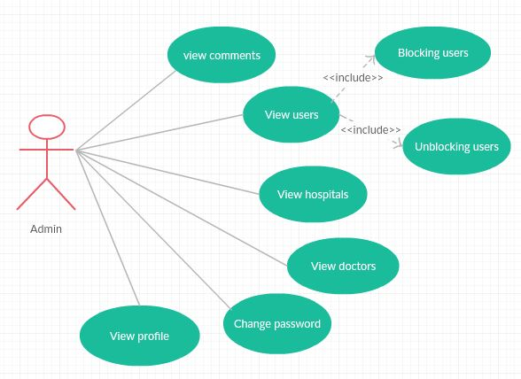
Figure4: Usecase for Admin

2.2 Programming files:

The programming files used in the system are
- Index.php
- Signup.php
- Patientlogin.php
- Adminlogin.php
- Userpage.php
- Doctorrecommender.php

- index.php:

It contains the code for starting page of the website. The login and Sign in pages are linked in this page. Apart from this, this page also consists of About and Contacts given in Navigation bar

Parameters: There are 3 parameters
- login
- signup
- contact

Flowchart: Once the website is opened, if the user is already registered with the website he can directly login to his account else he needs to register only then can he be able to login.
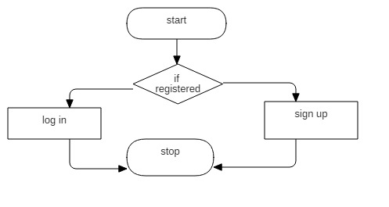
Function: In this page, the user needs to select either login or signup.if he is new he need to first register and the sign in.hence this page contains the simple code.it has two links ie sigup page and the login page.

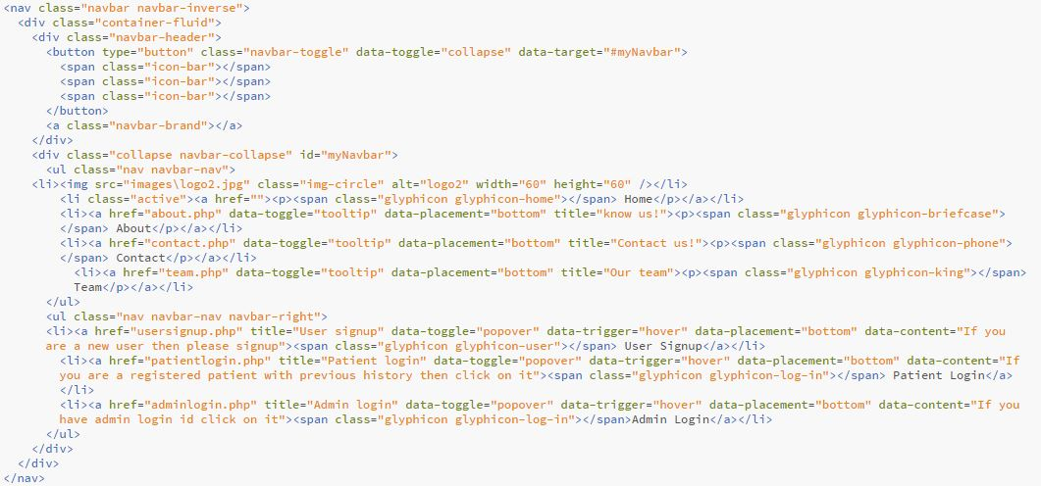

- Signup.php

Parameters:
The Parameters used in signup page are
- Username
- Password
- Confirm password
- Gender
- Age
- Email Id
- Contact Number

Flowcharts:

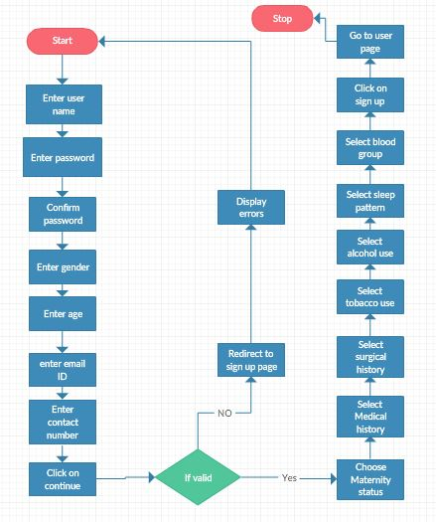

Function: On entering the registration page the user is expected to enter User Name without special characters. He or she then need to enter the password and again confirm the password. The user then needs to select gender and enter age. The user is expected to provide a valid Email id and a 10 digit valid phone number. Failing any of the conditions does not create an account for the user and the page is reloaded with the unsuccessful message. If the account creation is successful, the user is redirected to login page.

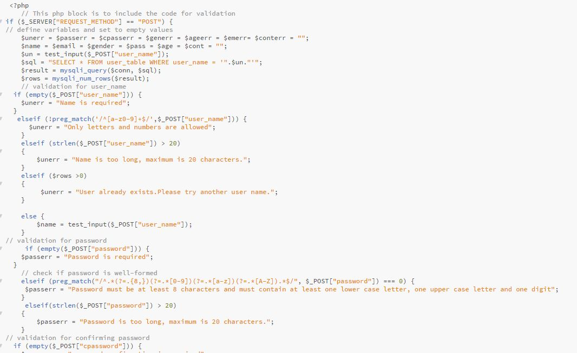
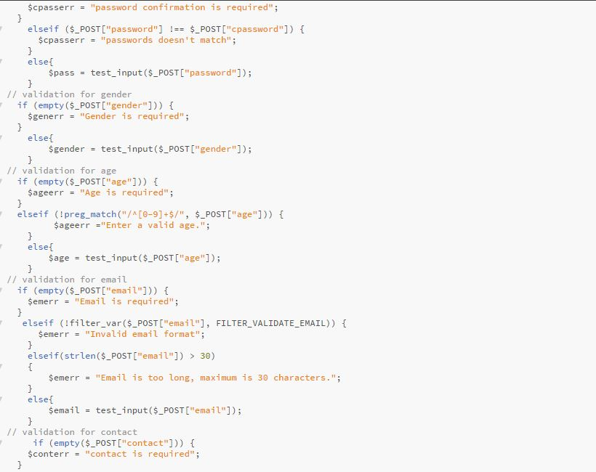

- Patientlogin.php

Parameters:
The Parameters used in Patient Login are
- User name
- User id
- Password
Flowchart:
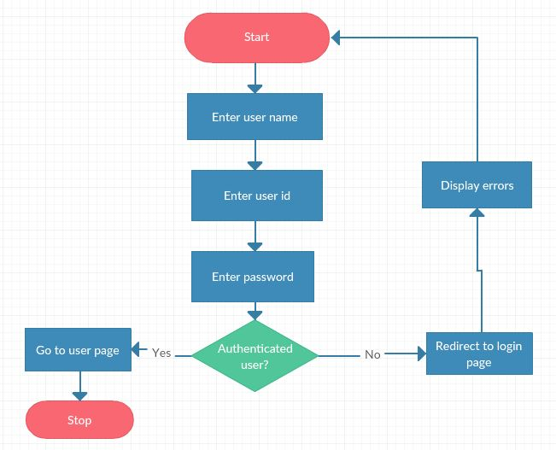

Function: On registering with the website, the patient is expected to enter the valid Username, User Id and Password associated with the website. Only then will the patient be able to login failing which he will be redirected to the same page by displaying an error “Incorrect Id or Password”
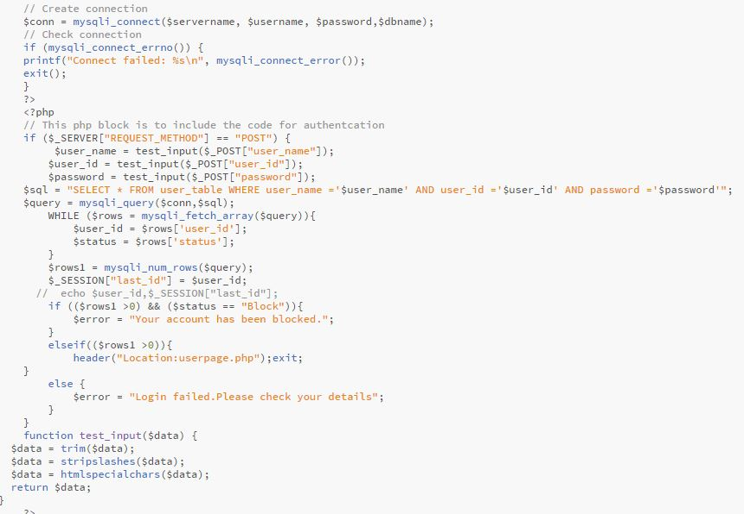

- Adminlogin.php

Parameters:

The Parameters used in admin login are
- Admin name
- Admin id
- Password

Flowchart:
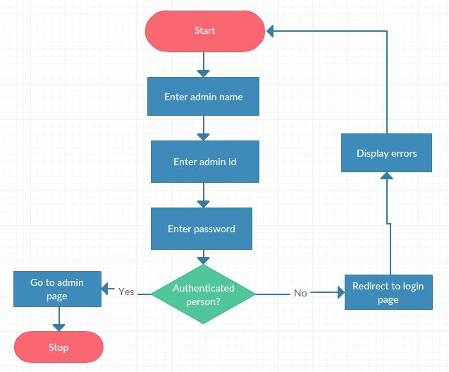

Function:
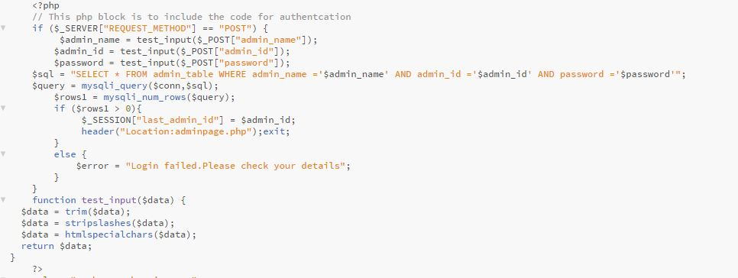
- Userpage.php

Flowchart:

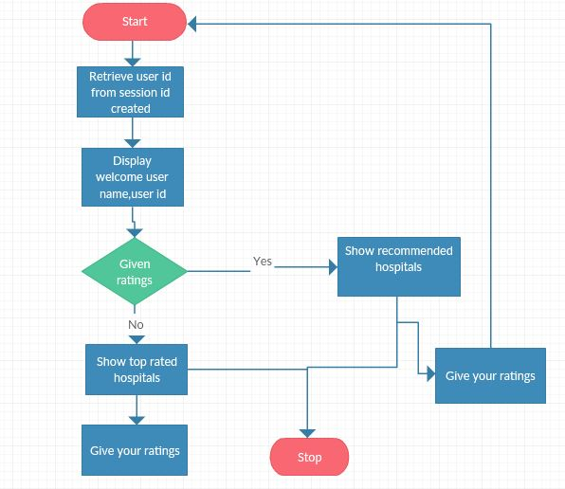

Functions:

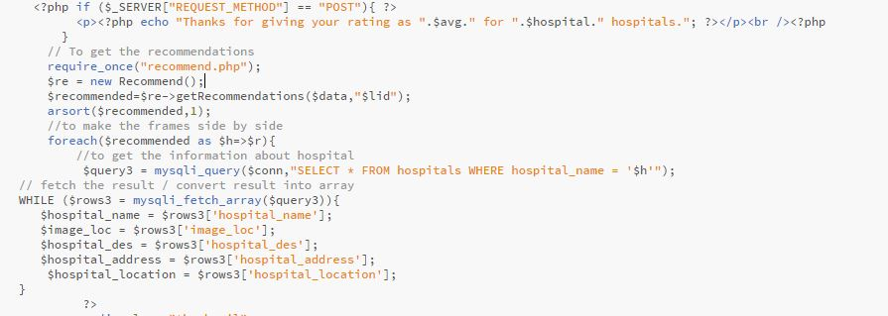

- Doctorrecommender.php

Parameters: Ratings are the only parameters here

Flowchart:
Initially, the website provides the user with the list of Top-rated Doctors across different specializations among which he can select any doctor that he wishes to. Once the user rates any doctor or hospital that he has been to, the website recommends him with doctors and hospitals similar to his ratings.
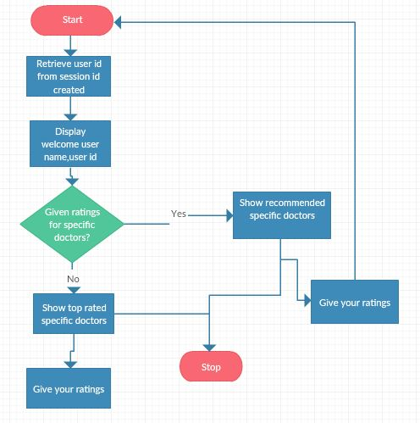
Functions:

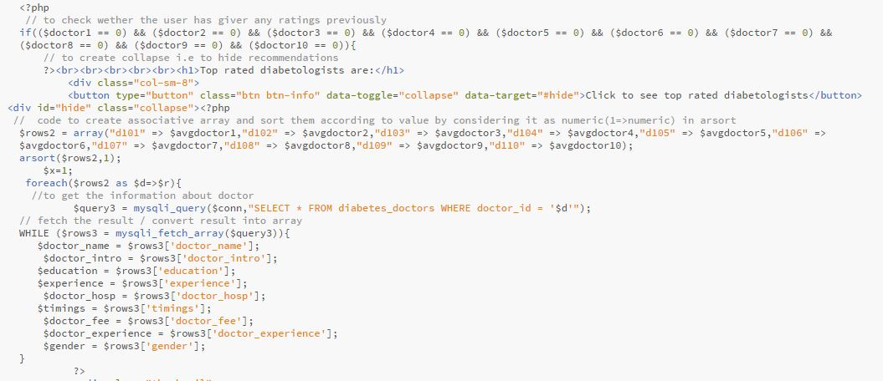

2.3 User Manual for each User case

The usecases associated in this project are:
- Give ratings
- View recommended hospitals and doctors
- Enter medical history
- Edit profile
- Write a message to admin
- Block users
- View comments and user
- View doctors and hospitals

User:
Give rating:
User can give his/her ratings to different doctors and hospitals to get appropriate recommendations. He/she can give their rating to specific doctor or hospital at a given time.
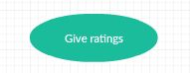

View recommender hospitals and doctors:
The recommendations given to the user are based on the rating which are previously given by them. The recommender function will find all the users who has given similar ratings as him/her, it will consider only these ratings to generate the recommendations for the user.
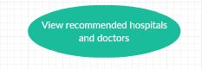
Enter medical history:
User can also store his medical history with us in order to refer it for further use. Medical history includes any medical issues, surgical history, tobacco use, alcohol use, exercise activity, sleep pattern, blood group.
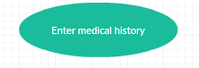
Edit profile:
User can update his profile data which is given while he/she is signing up. Everyone will have changes in their profile along time. Our site provides the user with flexibility to update his profile.
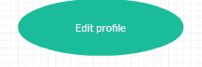

Write a message to admin:
User can write messages/complaints to admin. Every message of the user is considered by admin.
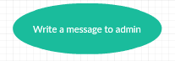
Admin:
Block users:
Admin can block user by clicking on a button to block/unblock a user. If the user is unblocked then the button displayed is to change his status from unblock to block. If admin clicks on it then the status of the user changes to block from unblock. Vice versa.
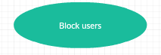
View users and comments:
Admin can view all the users who are registered. He can also go through all the messages/comments given by users.
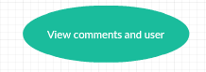
View doctors and hospitals:
Admin can view all the doctors and hospitals which are given in the database.
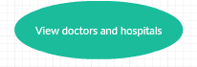

3. DATABASE/E-R DIAGRAM

In this project of Health Recommender Systems, the database has tables namely:
- user
- feedback
- doctor
- hospital
- admin

User Table
Attribute | Type
User_id | Int(20)
User_name | Varchar(20)
Password | Varchar(20)
Gender | Varchar(20)
Age | Int(20)
Email | Varchar(20)
maritualstatus | Varchar(20)
mhistory | Varchar(20)
shistory | Varchar(20)
Contact | Varchar(20)

shistory
Gender
Password
tobacco

User_id
User_id

exercise
Age
status
User
Email
alcohol
User_name
sleep
mhistory
maritualstatus

Contact

Feedback table
Attribute | Type
Message_id | Int(10)
Name | varchar(20)
Email | varchar(50)
Message | text
Datetime | varchar(30)

message_id

datetime
email
message
name
Feedback table

Admin Table
Attribute | Type
Admin_id | Int(10)
Admin_name | Varchar(20)
Password | Varchar(20)
Admin_pic | Varchar(30)

admin_id

admin_pic
password
admin_name
Admin table

Doctor Table
Attribute | Type
Doctor_id | Varchar(20)
Doctor_name | Varchar(100)
Doctor_intro | text
education | text
experience | text
Doctor_hosp | Varchar(200)
timings | Varchar(30)
Doctor_fee | Int(20)
Gender | Varchar(20)

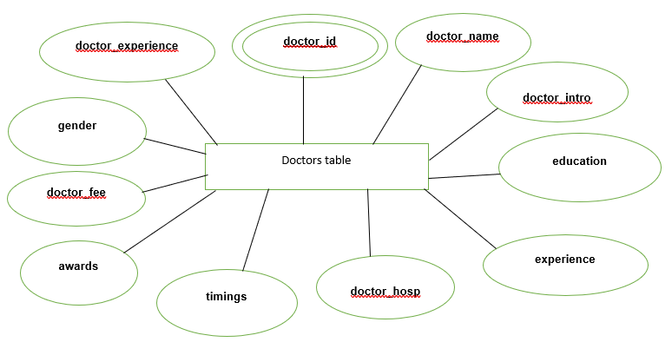
Hospital Table
Attribute | Type
Hospital_id | Int(20)
Hospital_name | Varchar(20)
Hospital_loc | Varchar(40)
Hospital_descrption | Text
Hospital_address | Varchar(200)

hospital_name
hospital_id
hospital_address

hospitals
hospital_location
hospital_des
image_loc

4. TEST CASES

INTRODUCTION
A test case is a software testing document, which consists of event, action, input, output, expected result and actual result. Test case defined as test case is an input and an expected result. It can occasionally be a series of steps.
TESTCASES IN PROJECT
Test Case ID | Test Case | Function Being Tested | Initial State | Input | Output | Status
001 | System Startup | System is started when server is started | System is off | Server is turned on | Index page | Success
002 | User signup | Validation | Signup page | User details | User page | Success
003 | Login | Authentication | Login page | Username  User ID  Password | User page | Success
004 | User page | Rating Inputs | Top rated hospitals | User ratings | Recommended hospitals | Success
005 | Doctor recommendations | Rating inputs | Top rated doctors | User ratings | Recommended doctors | Success
006 | User details page | Displaying user details | Displaying user details | Click on user profile | Display of user details | Success
007 | Edit user profile | Updating user details | Edit user page is filled with existing data of user page | New details of user | Display updating done successfully | Success
008 | Change password | Update user password | Change password page | New password of user | Displaying password changed successfully | Success
009 | Message | Creating a feedback of user | Auto filled user name and user id | User message | Displaying message sent successfully | Success
010 | Block users | To block and unblock users | Displaying status of user | Click on button | Blocks/Unblocks user | Success

5. DEPLOYMENT
5.1 Deployment Diagram:
A deployment diagram in the Unified Modeling Languages models the physical deployment of artifacts on nodes. To describe a web site, for example, a deployment diagram would show what hardware components ("nodes") exist (e.g., a web server, an application server, and a database server), what software components ("artifacts") run on each node (e.g., web application, database), and how the different pieces are connected (e.g. JDBC, REST, RMI).
The nodes appear as boxes, and the artifacts allocated to each node appear as rectangles within the boxes. Nodes may have subnodes, which appear as nested boxes. A single node in a deployment diagram may conceptually represent multiple physical nodes, such as a cluster of database servers.
There are two types of Nodes:
- Device Node
- Execution Environment Node
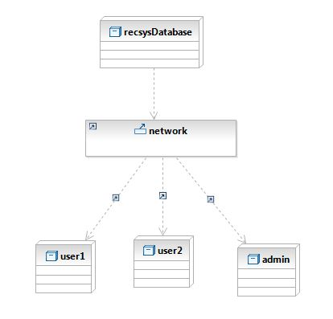

5.2 Screenshots
- User Signup Page

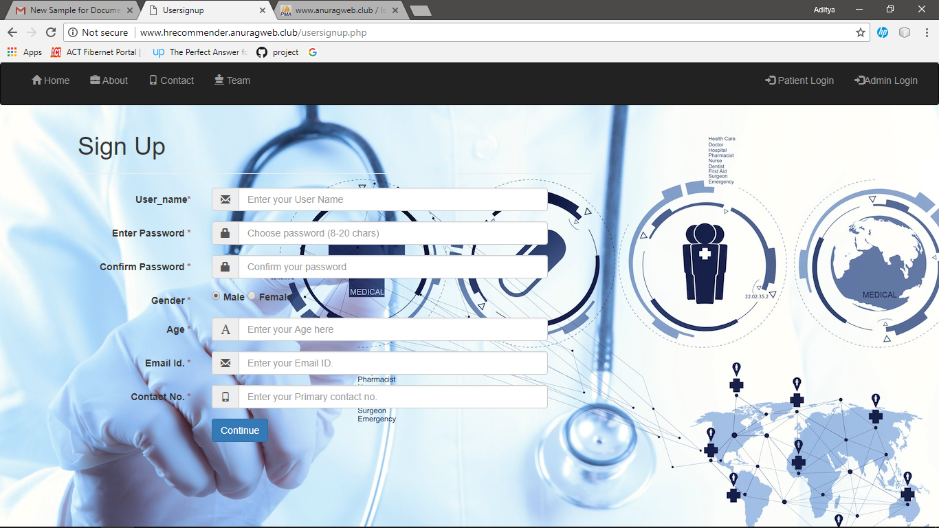
- Patient Login Page

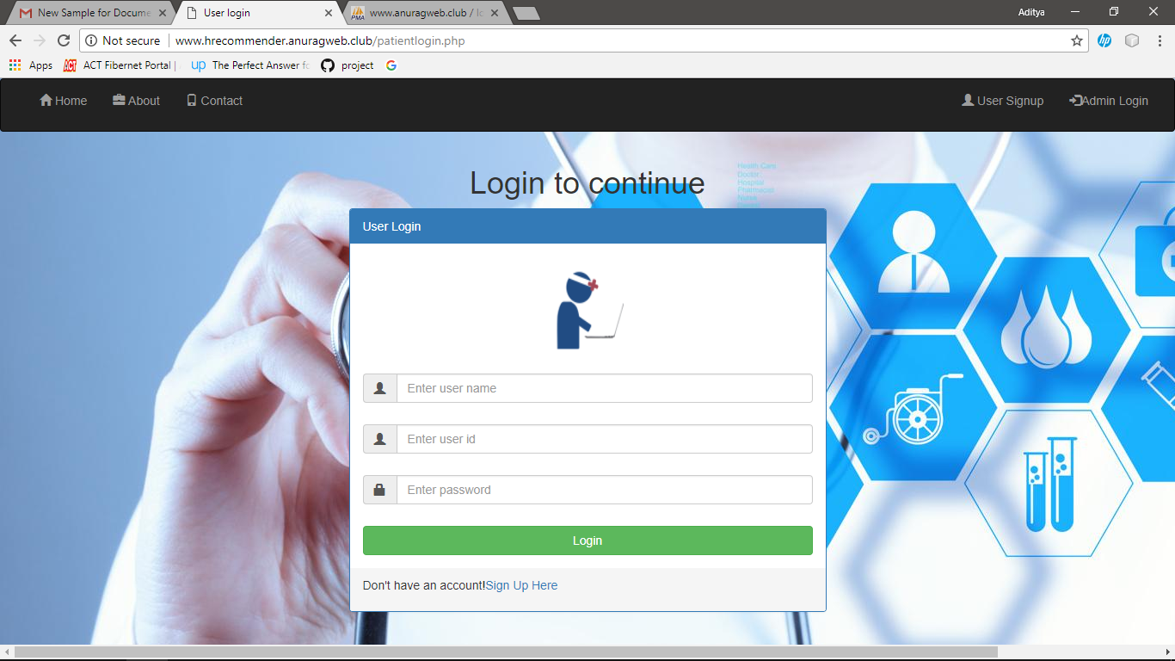
- Patient Home Page

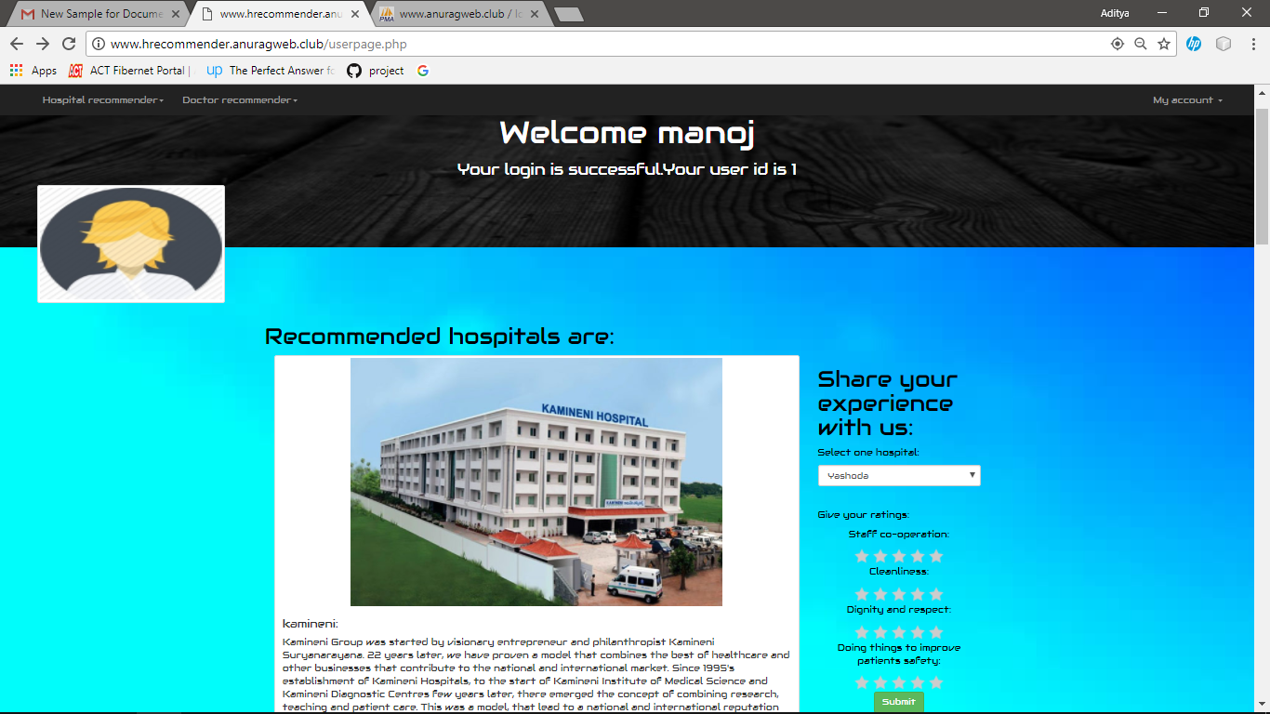

- Admin Login Page

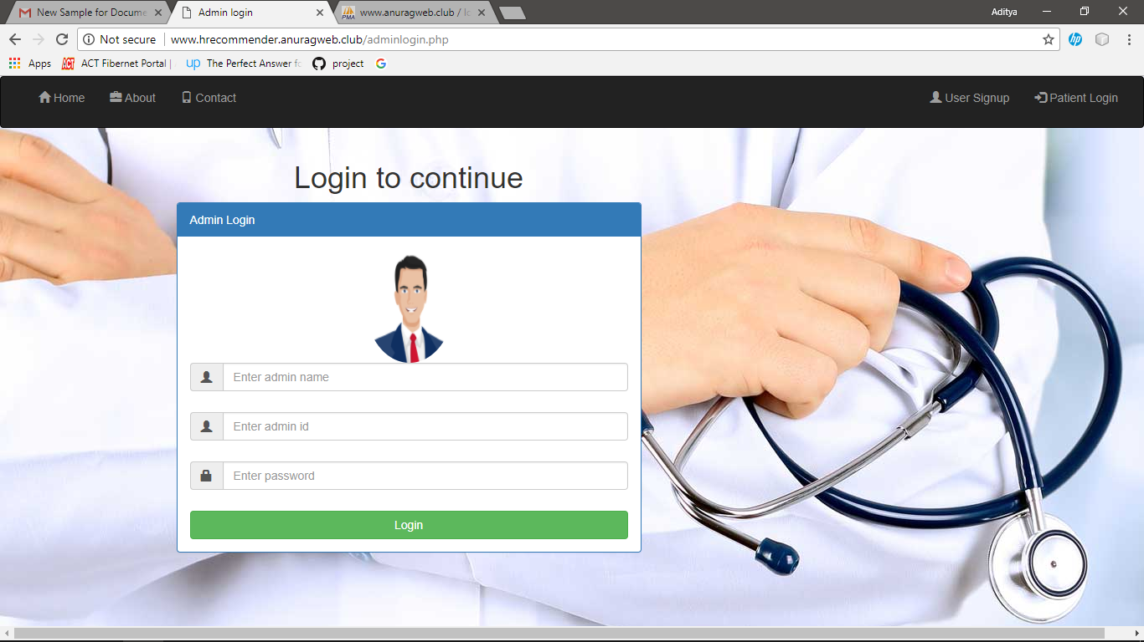

- Admin Home Page

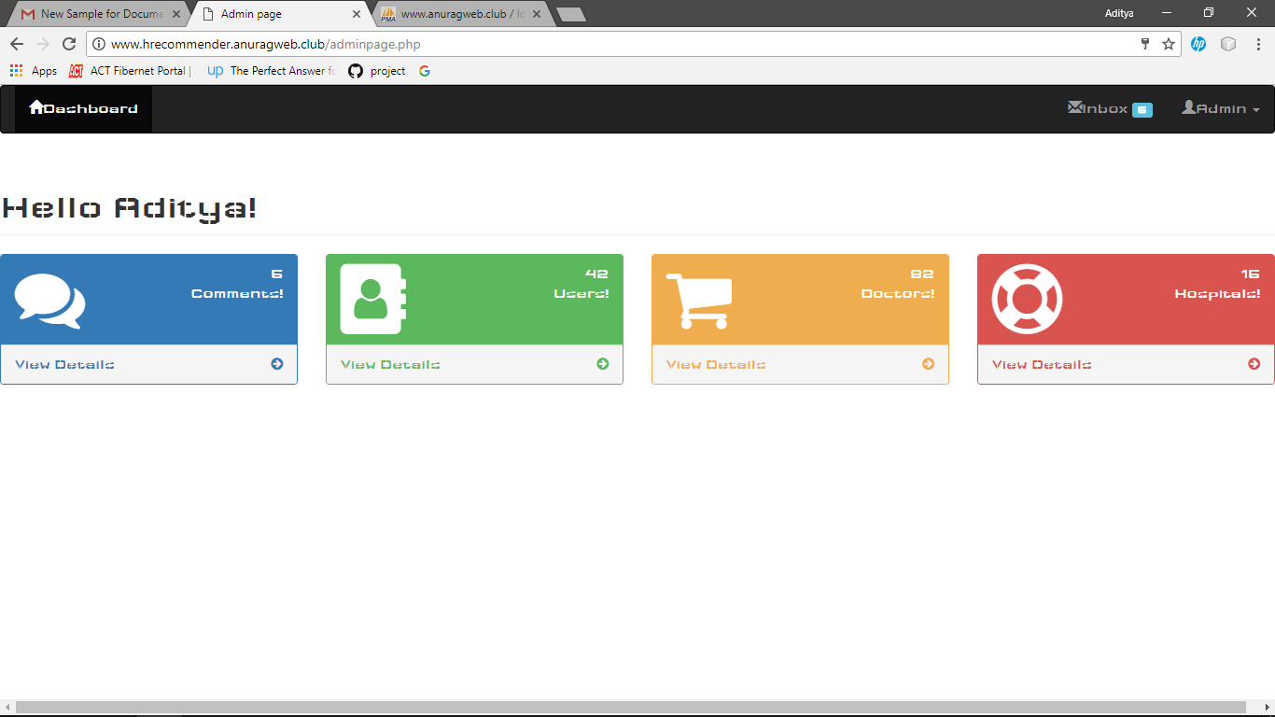

- Hospital Recommendation in User Page

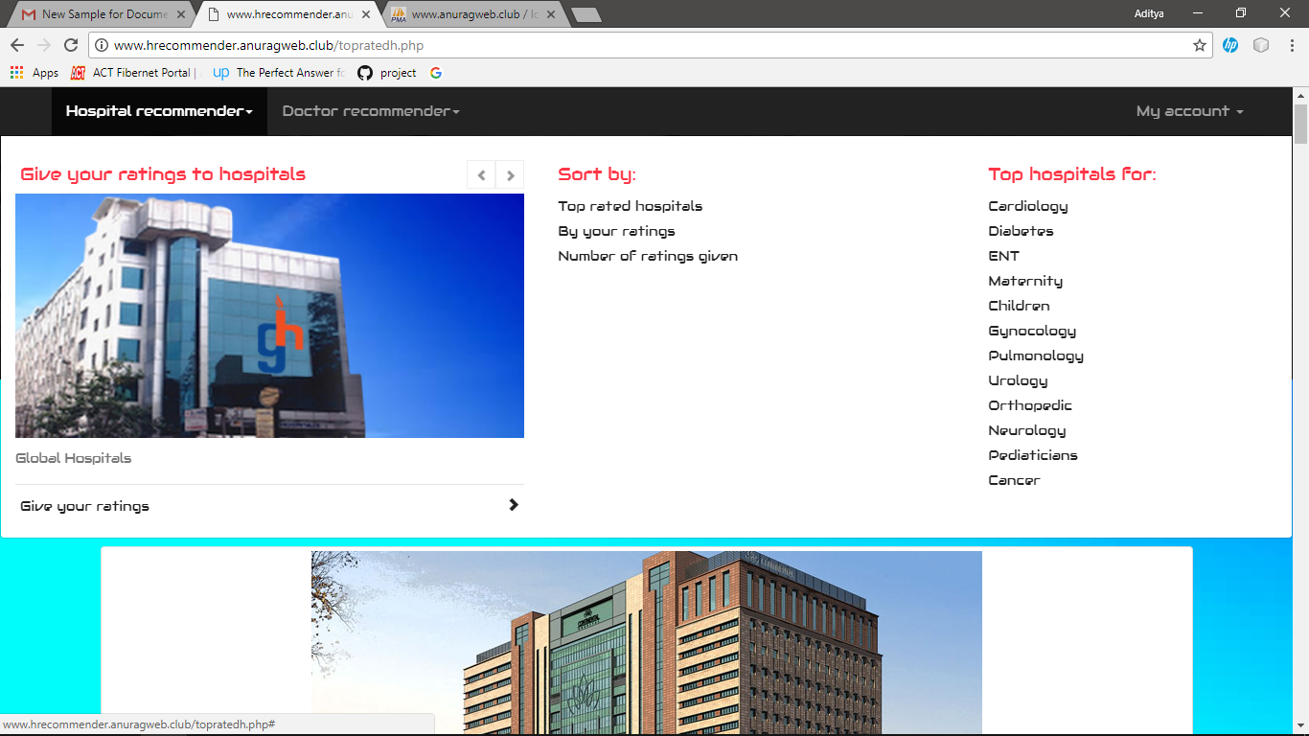

- Doctor Recommender in User Page

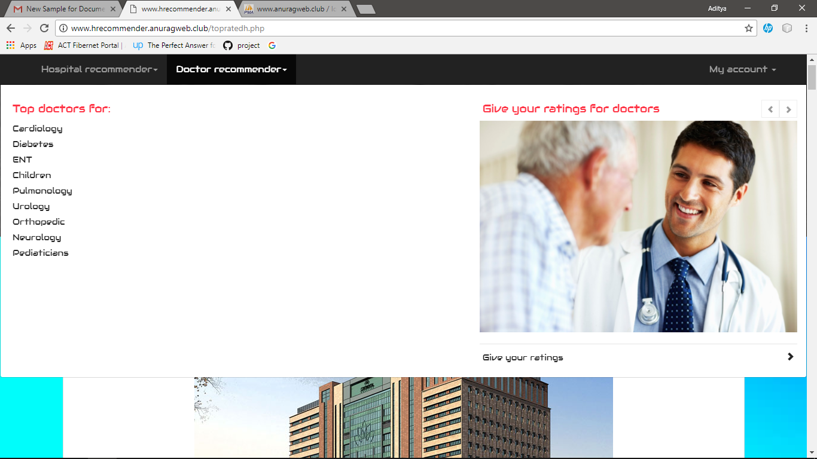

- Patient details in Admin id

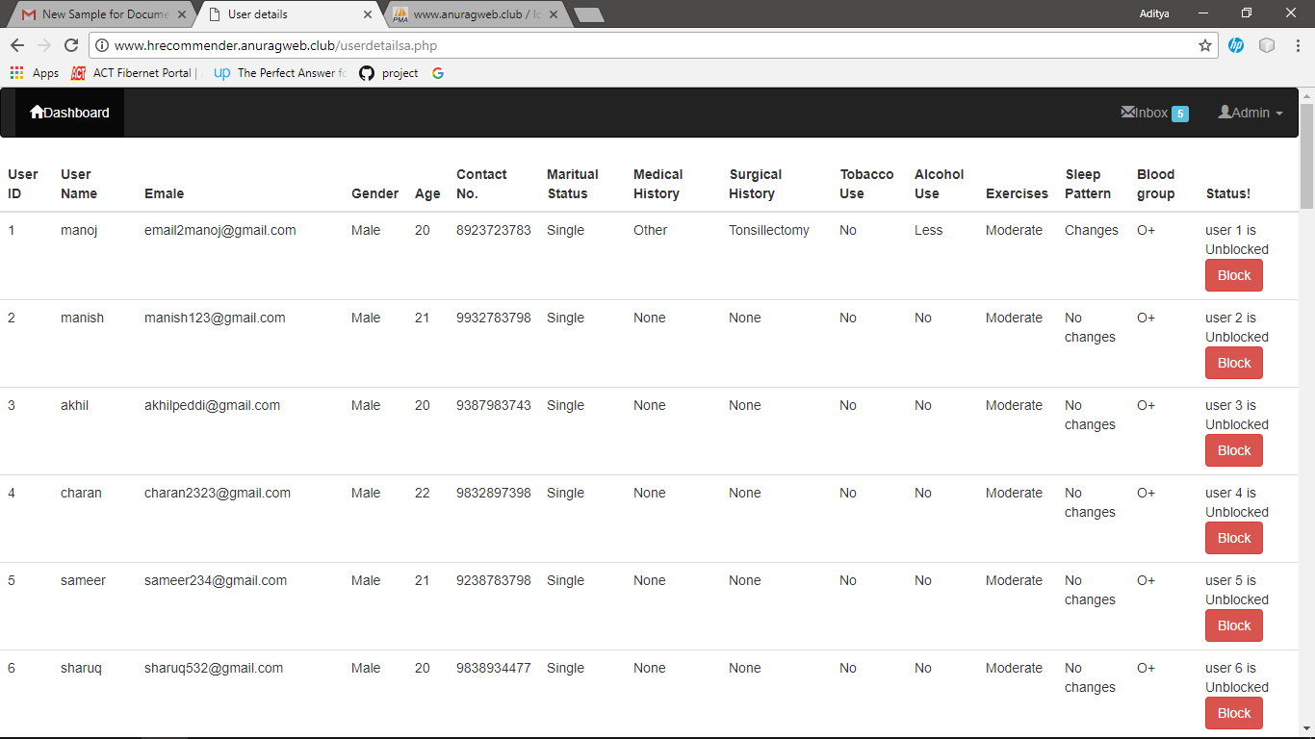

6. CONCLUSION

6.1 Project Conclusion
From the proper analysis of positive points and the constraints on the web application it can be safely concluded that the application is a highly efficient web based application for storing, managing, uploading, displaying the knowledge. This application can be easily accessed, customized according to needs. admin can easily add, view, update details of page
Also, the application is user friendly, reduces time and fast in response.

6.2 REFERENCES
- http://www.w3schools.com
- https://www.tutorialspoint.com/php/
- https://www.credihealth.com/doctors/hyderabad

